MEMORY MANAGEMENT

memory hirearchy :-

it contains cache memory , primary memory (main memory), secondary memory

primary memory stores currently instructed program and data only

in secondary memory :- here stores the program and data that are not actively needed

cached memory are extremely consist high speed as compared to primary and secondary memory , usually located in processor and mostly access to the data copy for faster access , so the data that will be executed which stores in cached

a processor may access program and data directly from the main memory and the cache but in secondary memory system must first move program and data to main memory before a processor may refer them , i.e before the program consider them the data and program tranfer to main memory and only the current instruction that may be executed will be stored in cached and again the result of the current instruction stored in primary memory and the primary memory send the current data into secondary memory so this is how the operation will be done

so in memory hirearcy as we move from down to up the storage access time decreses , storage access speed increases and storage cost per bit also increasing(i.e as compared to secondary storage , primary memory cost is more and also cache memory cost is highest as per bit increament) and storage capacity decreases

as we also represent as secondary storage contains folder and this folder move to primary storage , now primary memory tranfer a file one by one which present in the folder and then cached file transfer the data to the register and form the register cpu will take the data and execute the operation

0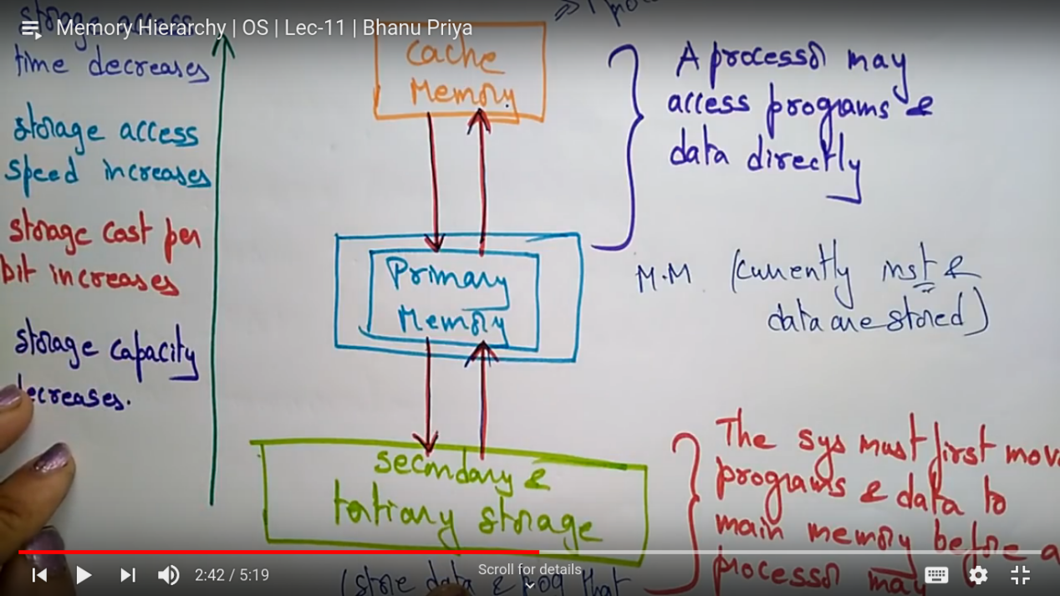

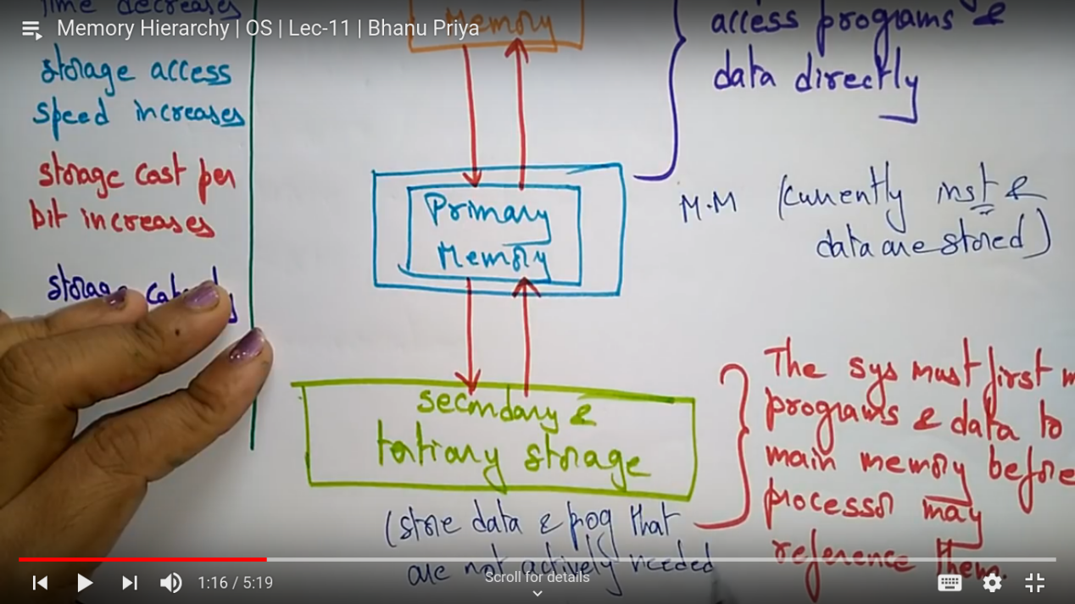

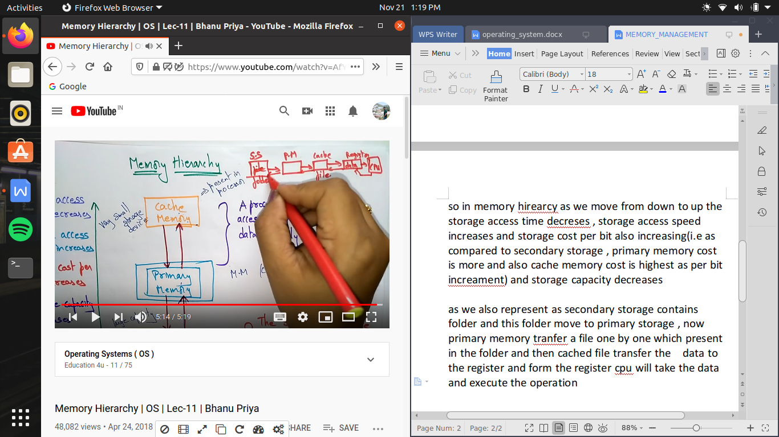

memory organization:-

a memory can be organized in different ways , one process uses entire memory space and each partition uses entire memory spaces or else each process gets its own partition in memory (that may be dynamically and statically allocated )